# Understanding Boolean logic

In this reading, you will explore the basics of Boolean logic and learn how to use multiple conditions in a Boolean statement. These conditions are created with Boolean operators, including AND, OR, and NOT. These operators are similar to mathematical operators and can be used to create logical statements that filter your results. Data analysts use Boolean statements to do a wide range of data analysis tasks, such as creating queries for searches and checking conditions when writing programming code.



## B​oolean logic example

Imagine you are trying to find shoes, but you will only buy them if they met a specific condition. Your condition could be, “If the color of the shoe has any combination of grey and pink, I’ll buy them.” The Boolean statement would break down the logic of that statement to filter your results by both colors. It could say “IF (Color=”Grey”) AND (Color=”Pink”) then buy it.” The AND operator lets you stack multiple conditions.

Here is a simple truth table that outlines the Boolean logic at work in this statement. In the Color is Grey column, there are two pairs of shoes that meet the color condition. And in the Color is Pink column, there are two pairs that meet that condition. But in the If Grey AND Pink column, there is only one pair of shoes that meets both conditions. So, according to the Boolean logic of our statement, there is only one pair marked true. In other words, there is one pair of shoes we can buy.

| **Color is Grey** | **Color is Pink** | **If Grey AND Pink, then Buy** | **Boolean Logic** |
| --- | --- | --- | --- |
| Grey/True | Pink/True | True/Buy | True AND True = True |
| Grey/True | Black/False | False/Don't buy | True AND False = False |
| Red/False | Pink/True | False/Don't buy | False AND True = False |
| Red/False | Green/False | False/Don't buy | False AND False = False |

The OR operator lets you move forward if either one of your two conditions is met. In the shoe example, you could say something like, “I will buy a pair of shoes if they are grey or pink.” The Boolean statement could be “IF (Color=”Grey”) OR (Color=”Pink”) then buy it.” Notice that any shoe that meets either the Color is Grey or the Color is Pink condition is marked as true by the Boolean logic. According to the Boolean logic, there are three pairs of shoes that you can buy.

| **Color is Grey** | **Color is Pink** | **If Grey OR Pink, then Buy** | **Boolean Logic** |
| --- | --- | --- | --- |
| Red/False | Black/False | False/Don't buy | False OR False = False |
| Black/False | Pink/True | True/Buy | False OR True = True |
| Grey/True | Green/False | True/Buy | True OR False = True |
| Grey/True | Pink/True | True/Buy | True OR True = True |

Finally, the NOT operator lets you filter by subtracting specific conditions from the results. For example, let’s say you wanted to buy any grey shoe except for those with any traces of pink in them. Your Boolean statement might be “IF (Color="Grey") AND (Color=NOT “Pink”) then buy it.” Now, all of the grey shoes that aren't pink are marked true by the Boolean logic for the NOT Pink condition. The pink shoes are marked false by the Boolean logic for the NOT Pink condition.

| **Color is Grey** | **Color is Pink** | **Boolean Logic**  **for NOT Pink** | **If Grey AND (NOT Pink), then Buy** | **Boolean Logic** |
| --- | --- | --- | --- | --- |
| Grey/True | Red/False | Not False = True | True/Buy | True AND True = True |
| Grey/True | Black/False | Not False = True | True/Buy | True AND True = True |
| Grey/True | Green/False | Not False = True | True/Buy | True AND True = True |
| Grey/True | Pink/True | Not True = False | False/Don't buy | True AND False = False |

Below are Venn diagrams that illustrate these concepts. AND is the center of the Venn diagram, where two conditions overlap. OR includes either condition. NOT includes only the part of the Venn diagram that doesn't contain the exception.

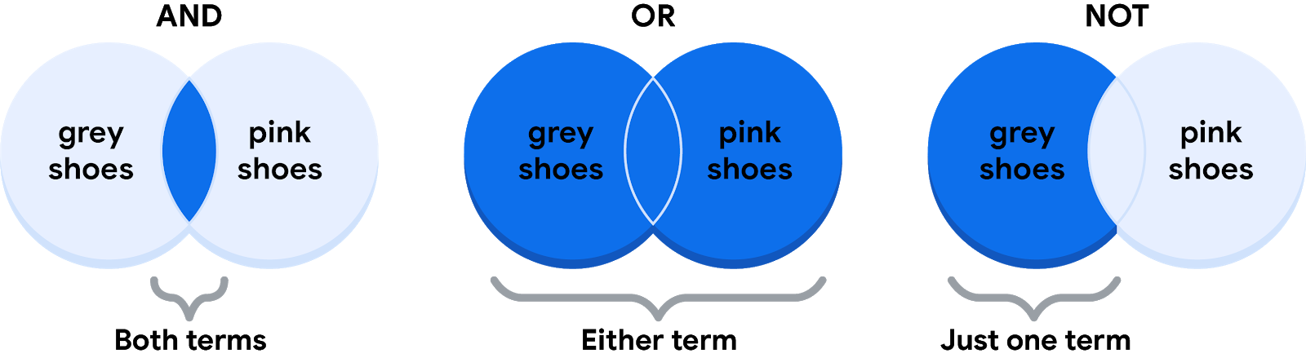

For data analysts, the real power of Boolean logic comes from being able to combine multiple conditions in a single statement. For example, if you wanted to filter for shoes that were grey or pink, and waterproof, you could construct a Boolean statement such as: “IF ((Color = ”Grey”) OR (Color = “Pink”)) AND (Waterproof=”True”).” You might notice that you can use parentheses to group your conditions together.

Whether you are doing a search for new shoes or applying this logic to your database queries, Boolean logic lets you create multiple conditions to filter your results. And now that you know a little more about how Boolean logic is used, you can start using it!

## Additional Reading/Resources

* Learn about who pioneered Boolean logic in this historical article: [Origins of Boolean Algebra in the Logic of Classes](https://www.maa.org/press/periodicals/convergence/origins-of-boolean-algebra-in-the-logic-of-classes-george-boole-john-venn-and-c-s-peirce).
* F​ind more information about using AND, OR, and NOT from these [tips for searching with Boolean operators](https://libguides.mit.edu/c.php?g=175963&p=1158594).